**Report Viewing Styles -** There are two options available.

**“Tiles”**

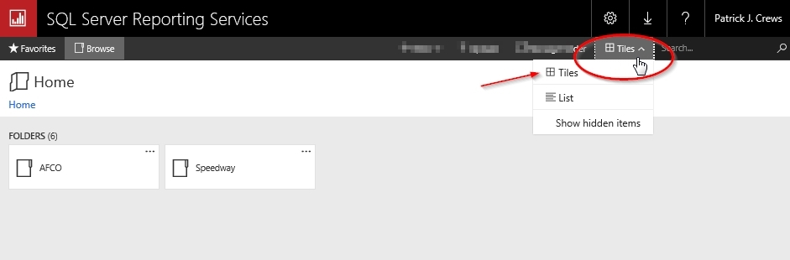

**“List”**

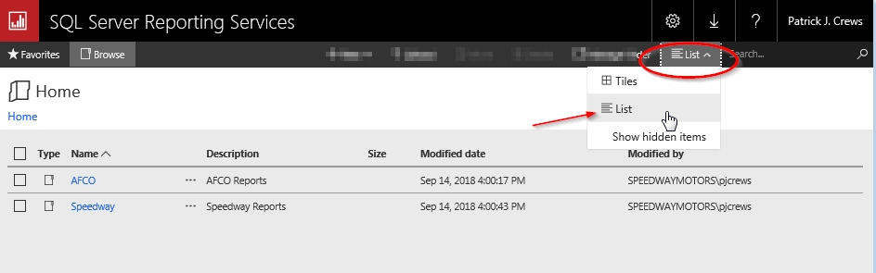

**Favorites –** If there are reports that you run often (or some that you rarely run and you just never remember what folder they’re in), you can add them to your Favorites.

1. Right-click the report (or click the 3 dots) that you want to add to your Favorites.
2. Click “Add to Favorites”
3. You can access your Favorites from ANY Reporting Services screen.

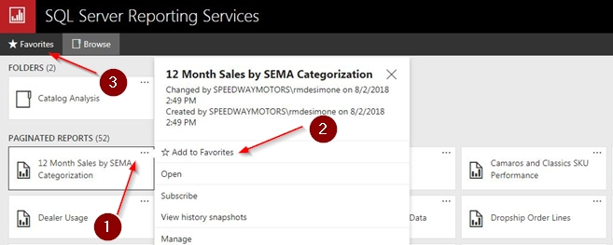

**Report Subscriptions** – You may create report subscriptions for most reports*. They will run on a schedule that you select and email the recipients you enter.

\**Some reports require input from the user every time they are run and the values change each time. In these cases subscriptions would not be useful. e.g. A report that asks for a specific catalog and a date range that changes.*

1. Right-click the report (or click the 3 dots) that you want to subscribe to.
2. From the pop-up menu select “Subscribe”

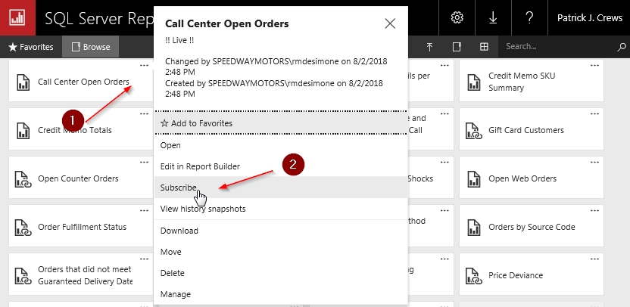

1. In the Schedule details section, select the schedule you would like the email reports sent on. Click the gray AM/PM box to toggle to the appropriate choice.
2. Once your changes are applied, the report subscription will automatically run the next time the scheduled time occurs. Start and end dates only need to be selected if you want the subscription to run for a limited date range. E.g. (you will gone for 2 weeks and have someone monitoring a report until you return)
3. Click Apply to save your changes

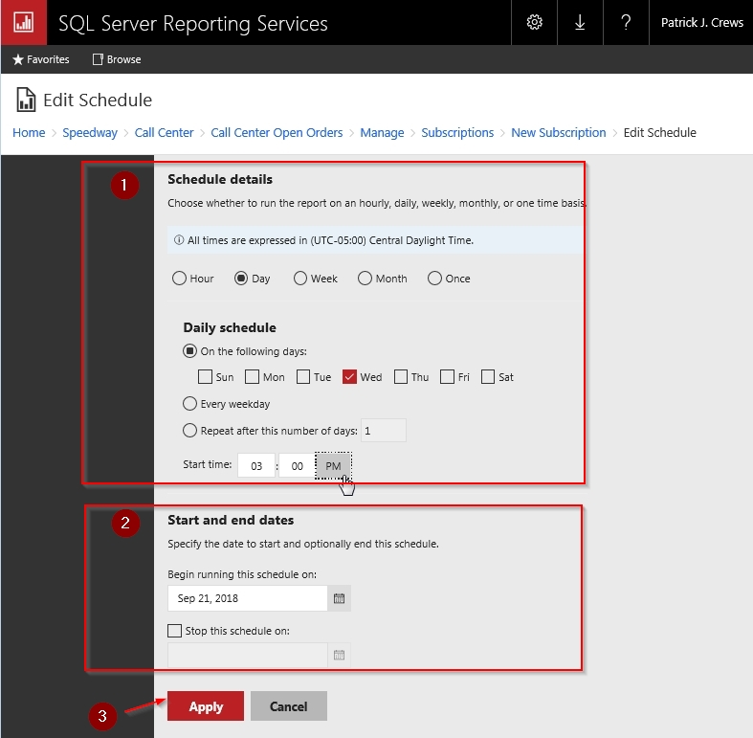

1. Enter the recipients who will receive the report. Be sure to place a semi-colon ( ; ) between each email address
2. The default subject line is the name of the report and the time it was run. You may enter a different subject if you prefer.
3. If you would like to enter any text in the body of the email you can enter it in the Comment section.
4. Some reports require input parameters when they are run. Those that are used by the report will appear here. Many of them have default values that won’t need to be changed (a date range for the previous 7 days for example). If you need to change a value just select the “Use default value” dropdown and it will allow you to select/enter your own value.

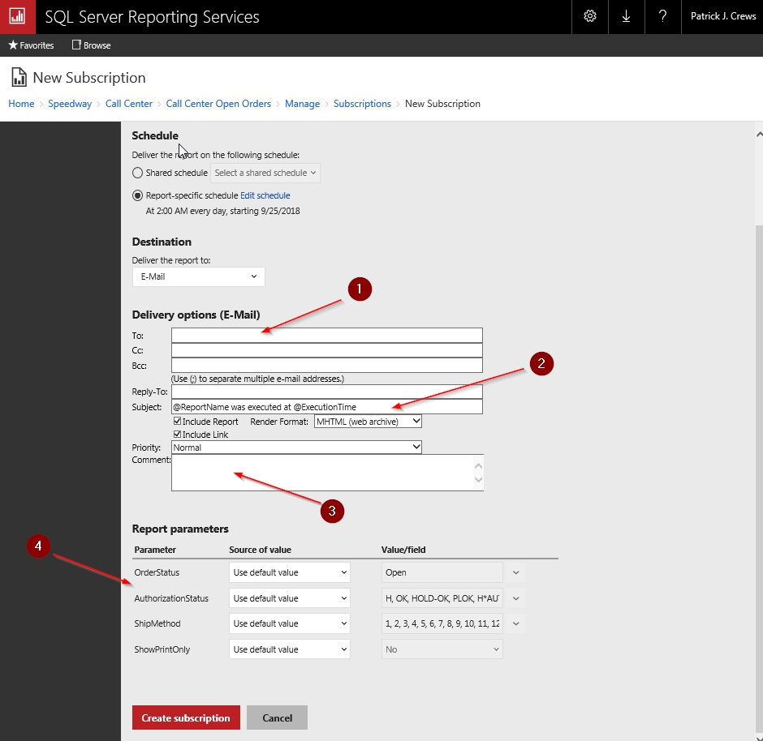

To see all of your report subscriptions:

1. Click the “Settings” button
2. Select “My subscriptions”

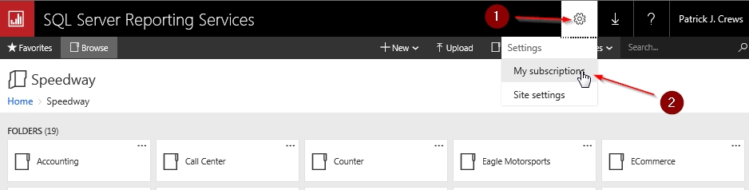

You will then see a list of every report subscription that you have created.

1. Click any column header to sort the list by that header. Click it again to sort it in reverse order.
2. Select the check box to edit a single subscription (for example if you want to change the schedule it’s delivered or add/remove recipients). You may select multiple subscriptions if wish to delete or disable (shut off) multiple subscriptions in a single action.

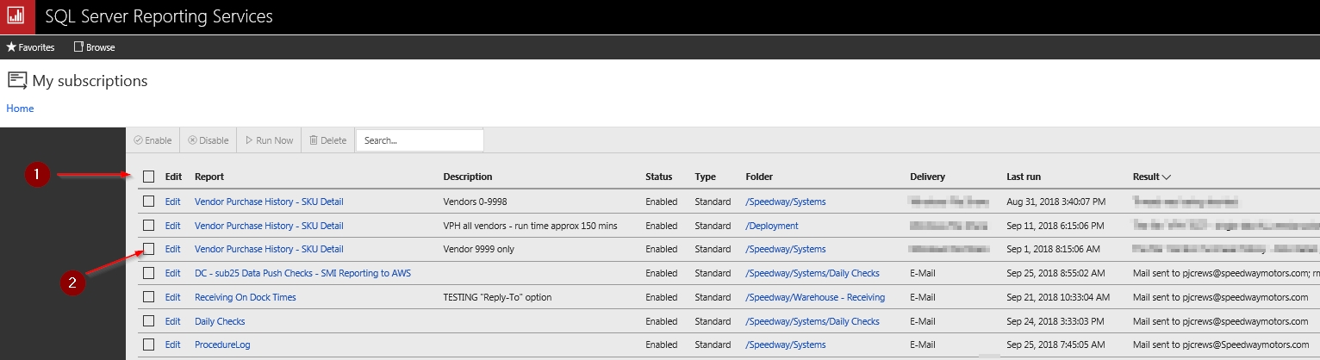

**Search** – Need to find that one report that you can’t remember the exact name of or what folder it’s in? Just enter a value in the search field from any screen in reporting services.

